About the Texas Future Farmers of America (FFA)

What is Texas FFA?
The Texas FFA is a student organization for future leaders who use scientific, agricultural learning to solve real world problems. Founded in 1929, today the organization is over 137,530 members strong and facilitates more than $2.3 million in scholarships every year.

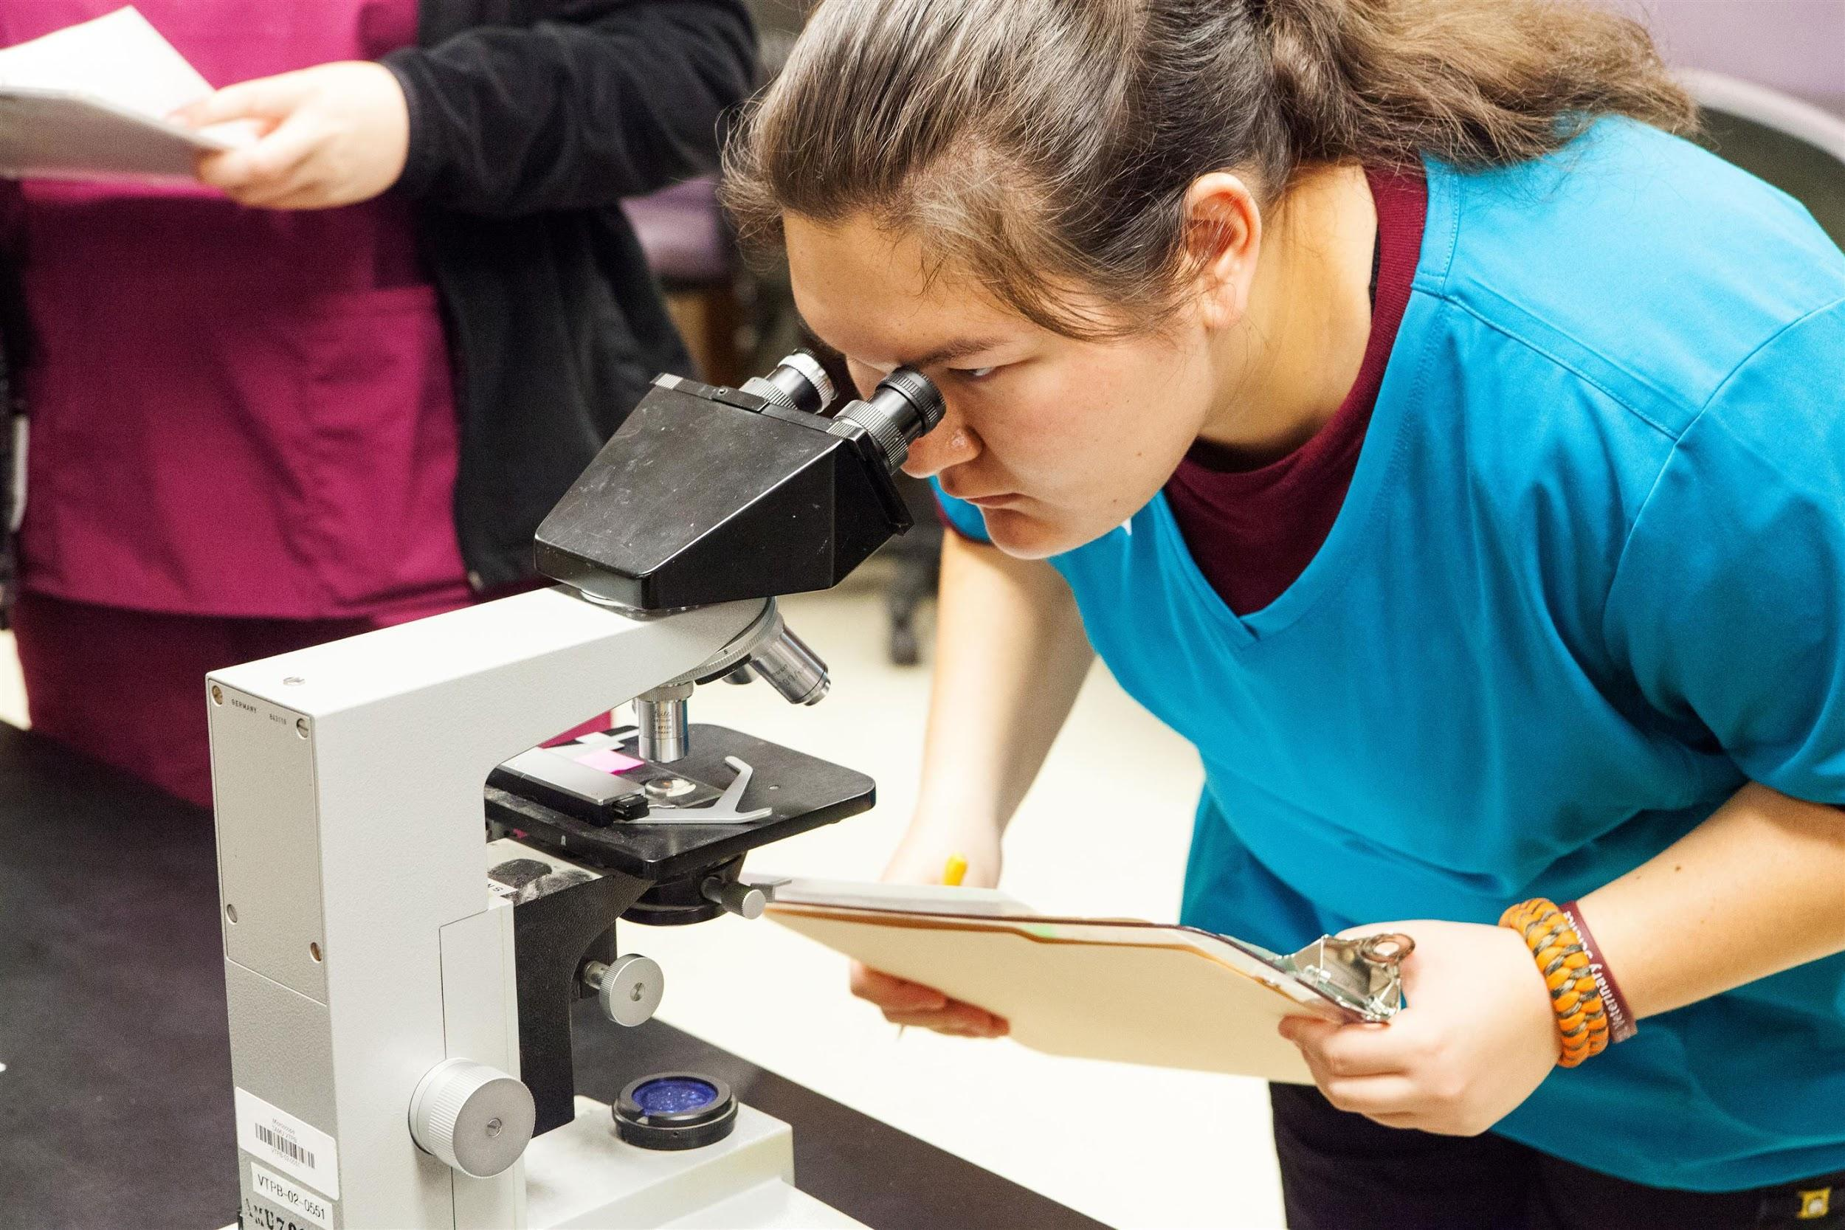
Why Agricultural Education is an Ideal Launching Point for Every Career
Agricultural education can be applicable to every field, not just farming and ranching. Today, agriculture encompasses science, design, research, business principles, marketing, and much more. From floral design to computer science, research and development to modern medicine, our students find limitless opportunities to discover the best in themselves while learning values that last a lifetime.

The Texas FFA has launched noteworthy business careers, established CEOs, and played an integral role in creating some of the state’s most respected leaders. We are the Future Farmers of America, but we are also the future biologists, future engineers, and future entrepreneurs.

How the FFA Works
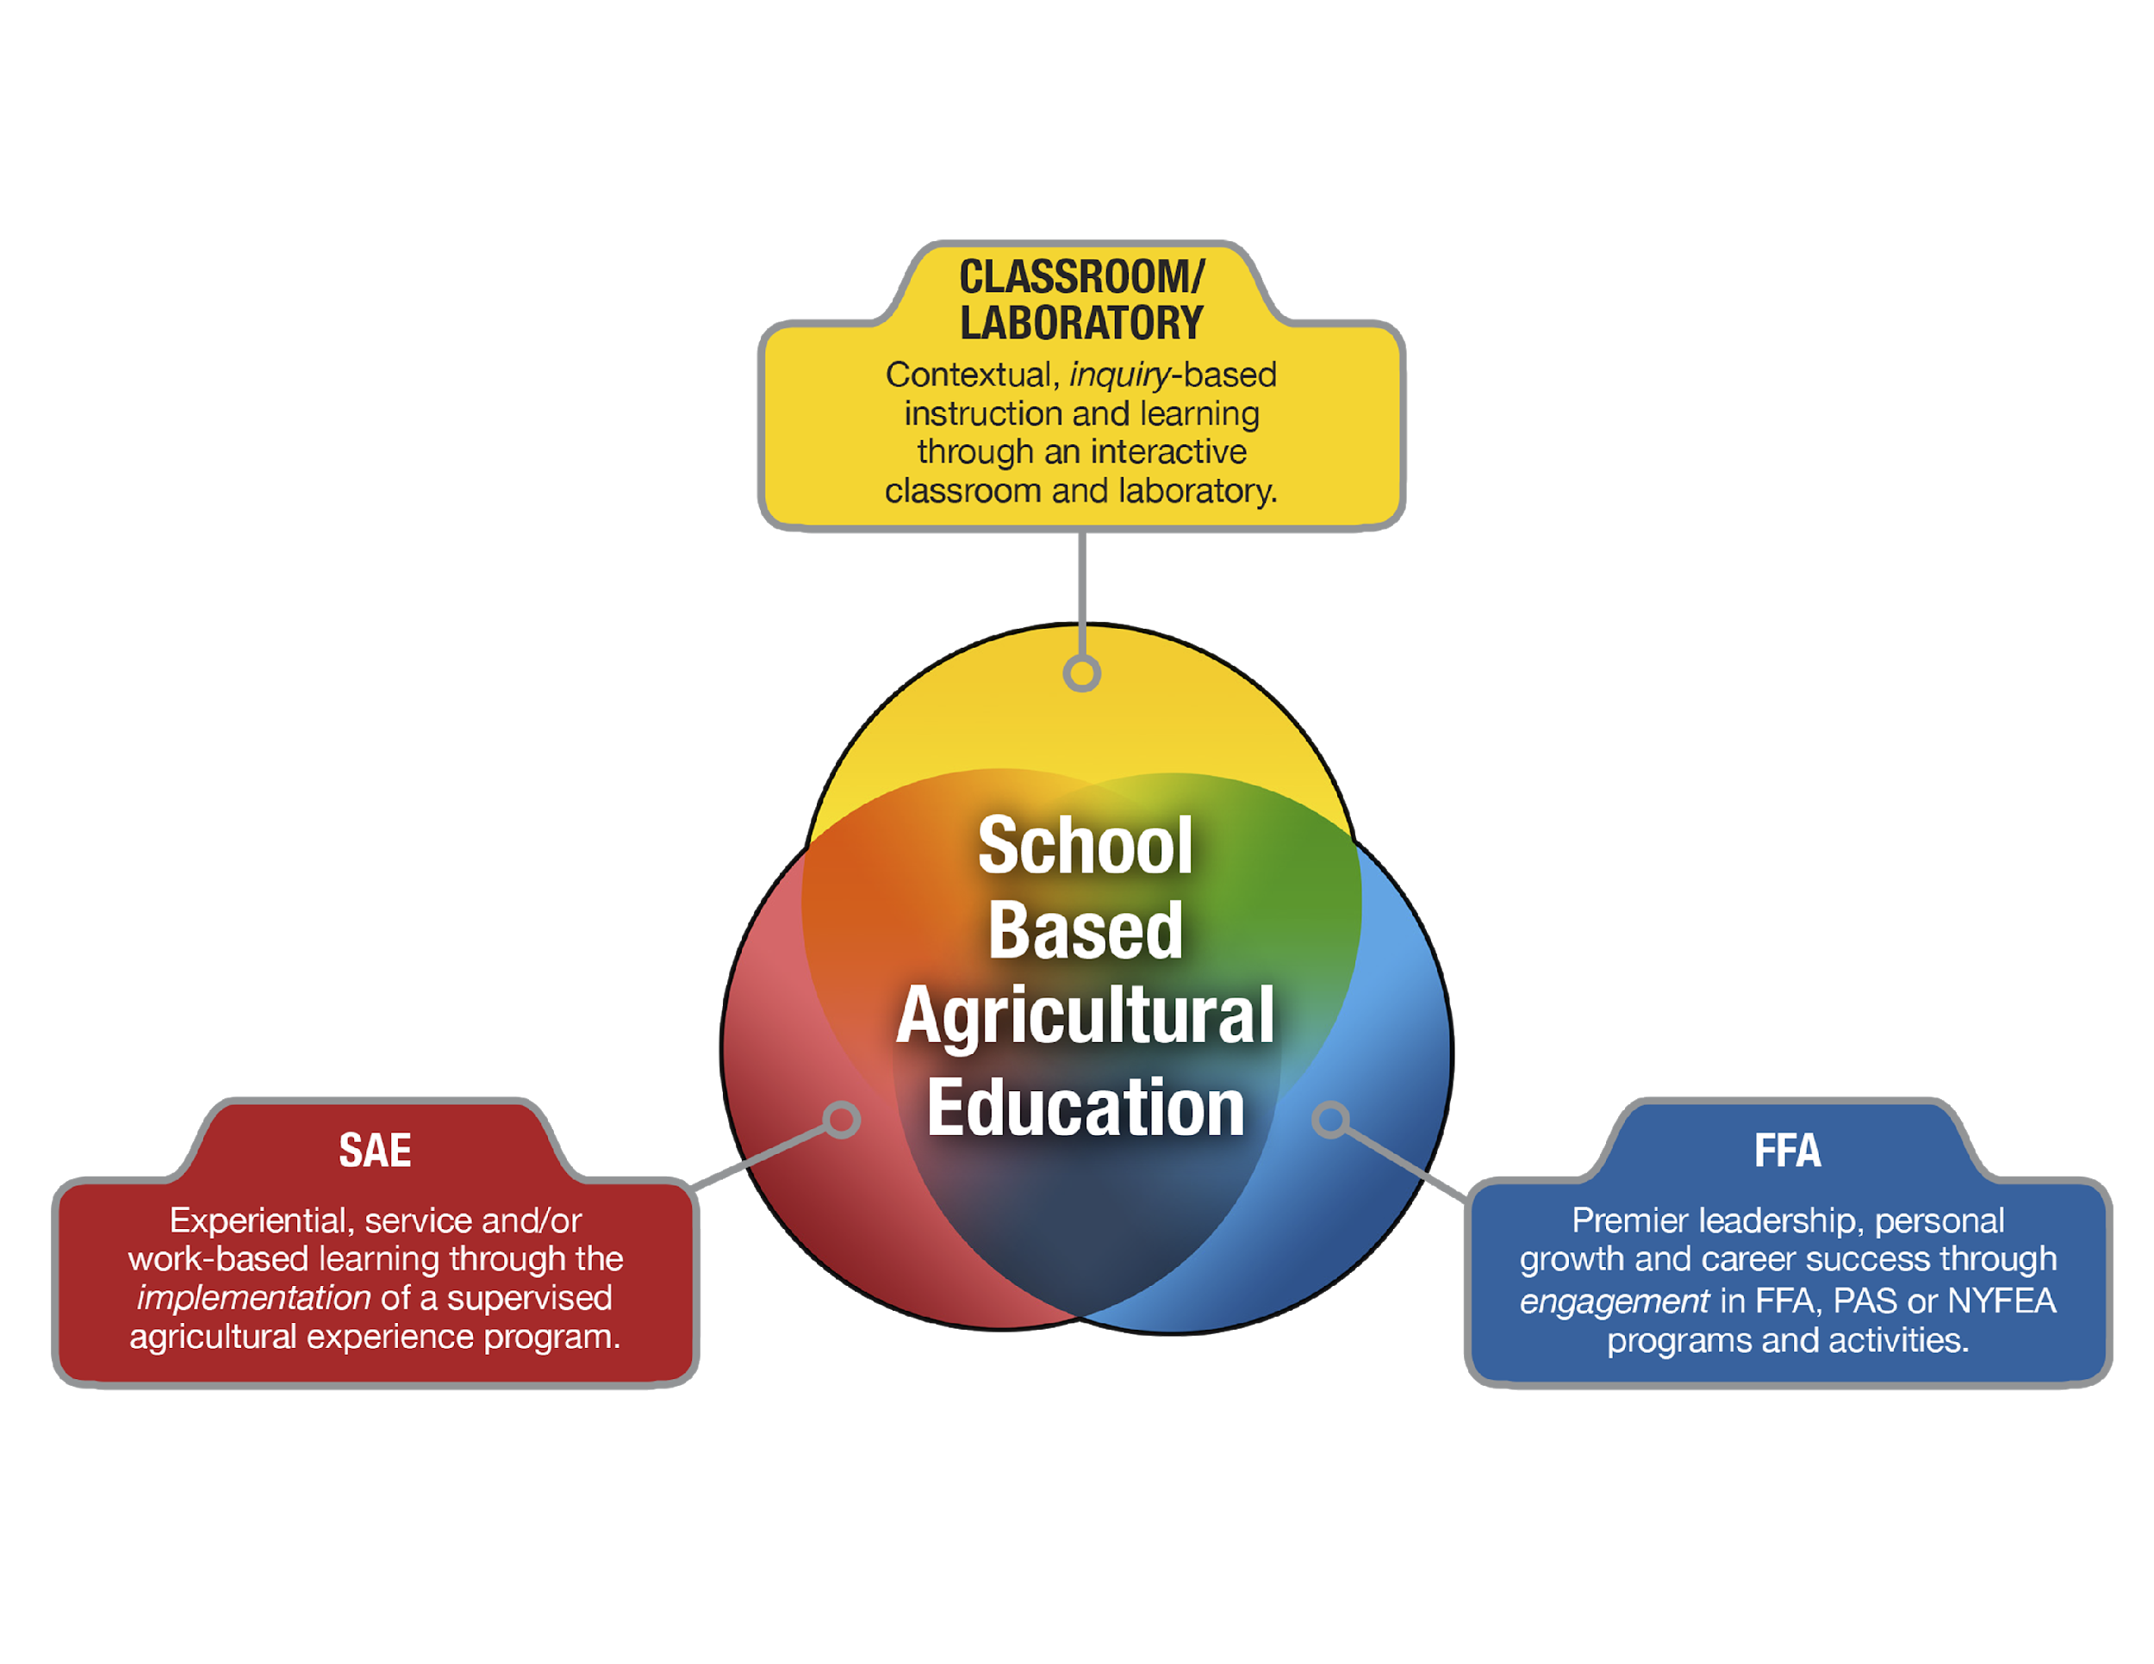
The FFA program is one facet of a three-part model of education that includes classroom instruction and supervised agricultural experiences (SAEs). In short, the FFA is where classroom learning starts applying to the real world. The FFA generates scholarships, hosts public speaking competitions, empowers student elected leadership committees, sponsors life changing mentorship opportunities, puts on science fairs, and facilitates an annual convention with more than 14,000 attendees. All FFA programs contribute to career exploration, success, and development.

A 92-year History with a Bright Future
The Texas FFA was founded in 1929, at a time when many people needed direction. The organization created a leadership program that offered greater opportunity for self-expression, leadership development, and a sense of pride in one’s work. Today, the FFA trains tomorrow’s leaders by emphasizing the intrinsic values that help living things grow and thrive. The FFA’s cornerstone values of respect, responsibility, and resilience continue to guide the organization as agriculture evolves to meet the world’s growing food supply demands.

Where Every Student Has a Place and a Purpose

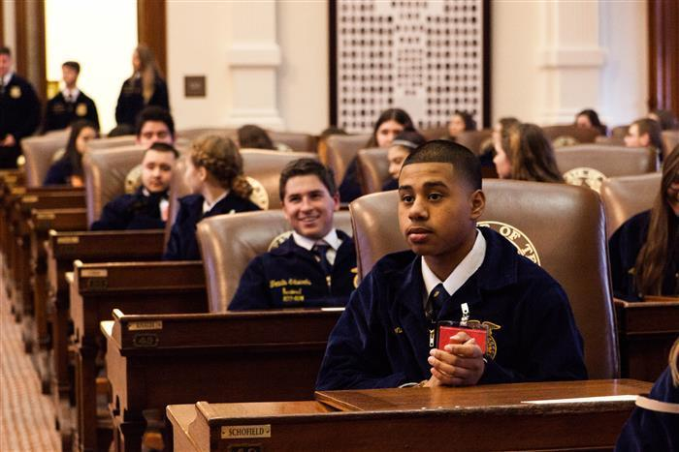
Scholarships that Can Change Futures
Each year, the Texas FFA facilitates the distribution of more than $2.3 million in scholarships. Awards range from $1,000 to $20,000, from one-time prizes to four-year awards. Many high school students who graduate with advanced placement credits are rolling these funds over to pay for their post graduate degrees. Scholarships are based on both academic and FFA achievements as well as candidate performance during interviews. With the FFA, every student has the opportunity to go further.

How We’ve Evolved
The Texas FFA was first founded in 1929. In 1969, the FFA welcomed its first female members, and today more than one third of Texas FFA members are women. In 1973, Texas native Fred McClure was the first African American elected to a national FFA office. Aaron Alejandro became the first Hispanic Texas FFA President in 1985 with Trey Elizondo later becoming the first Hispanic National FFA Officer from Texas in 2016. In 1990, Lesa Ann King became the first female National FFA Officer from Texas, while Erica Clarke became the first female Texas FFA President in 1991. In 2003, Benita Hodge became the first Black female to receive the Lone Star Degree. Texas FFA is proud to welcome all members equally, offering countless opportunities to grow and excel.

Agriculture and Beyond
Texas AgriScience’s broad course catalog and the FFA’s hands-on experiences instill values and life lessons that apply to every field. The FFA has kickstarted the careers of farmers and ranchers, but also politicians, CEOs, biologists, engineers, entrepreneurs, and more. Our alumni network is strong because the FFA’s core values serve members for a lifetime. Everyone can find ways to grow in the FFA, no matter what they’re interested in.
- Science
- Veterinary Medicine
- Technology
- Business
- Equipment Design
- Processing
- Engineering
- Public Service
- Mathematical Applications
- Ecology Management
- Floral and Landscape Design
- Mechanics
- Marketing and Communications
FFA Values Last a Lifetime

The Kind of Employees Companies Want to Hire
The FFA believes in core values that stand the test of time. That’s why the organization continually invests in respect, responsibility, and resilience, the same codes of conduct and personal character that remind us to serve the greater good and successfully deliver us from one era to the next. The FFA is about inclusion, ethics, integrity, character, passion, excellence, service, and community. These lessons apply to every career field, and they’re what make FFA members top job candidates for so many employers.

Preparing Leaders to Solve Tomorrow’s Most Pressing Problems
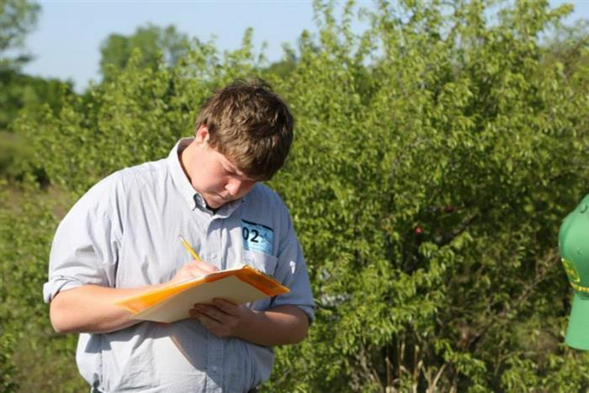
The United Nations estimates growing populations will require a 30-70 percent increase in food production by 2050, which must be accomplished with the same amount of land, water and natural resources we have today. Of the 70 percent more food required, it must come from technology and science that will improve and enhance efficiencies. Science has the ability to enable food producers to provide more high-quality products using fewer resources. To sustain a growing world, agriculture must achieve food affordability, supply, safety, and sustainability.

The lessons learned in the FFA apply to a wide range of careers and industries. Where do you fit?
So, you want to be a... Texas Agriculture Science Education offers…
Doctor Veterinary Medical Applications
Business Professional Professional Standards in Agribusiness
Inventor Energy and Natural Resources Technology
Artist Floral Design
Researcher Horticulture Science
Designer Agricultural Structures Design
Marketer Agribusiness Management and Marketing
Scientist Advanced Animal Science
Public Service Public Speaking Competitions
Engineer Agricultural Mechanics and Equipment Design

FFA Members Deal with Real World Problems

FFA Members Remain Resilient During the COVID-19 Environment
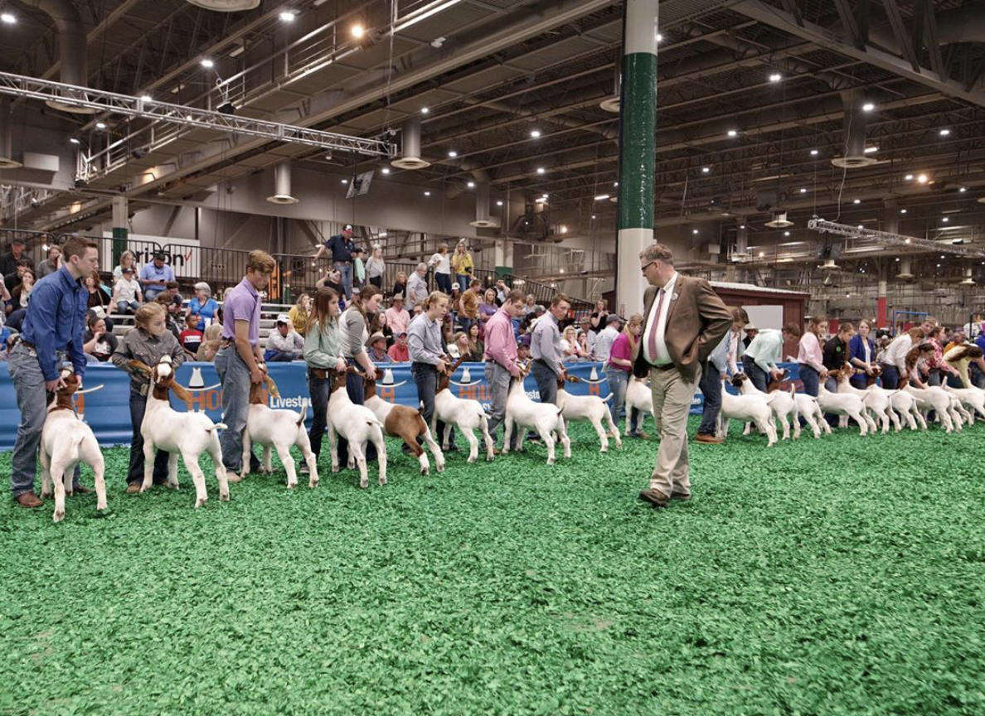
Every year FFA students throughout the state travel to Houston in the spring for the annual Houston Livestock Show and Rodeo, one of the biggest events of the year. The event was cancelled on March 11, 2020 due to the spread of the coronavirus pandemic, leaving many agriculture students and teachers without the opportunity to participate in the highly anticipated events and competitions.

Even with the disappointment of cancelled events, Texas FFA members were able to see the silver lining. The dedication and hard work each member puts into every project gives them crucial learning experiences and real-world circumstances.

“It caught a lot of people off guard, and we weren’t expecting it,” said Austin Large, executive director of the Texas FFA Association. “I think what is most important to remember is a lot of the learning our students do happens long before they even step on the rodeo grounds. That is the end point for their livestock portion and project -- they’re hoping to win big and sell big at the Houston Livestock Show and Rodeo -- but all of the work leading up to that, the responsibility it took, the relationships they formed and the mentorship, that all took place before they stepped foot on the rodeo grounds.”

Following the cancellation of all events in the spring, Texas FFA made the difficult decision to have all of its summer programming, including State Convention and ATAT Conference, to take place virtually.

“It starts way before the show,” said Jeremy Charchalac, Texas FFA member. “The instant you get that baby hog and put him on the trailer, you know that’s a commitment that you are making with the animal. From that point on, that animal is your partner. You have to have the commitment to be there day and night. Even if that cancellation wasn’t there, everything you learned and gained still stays with you. That still is something you take way beyond even after you have that animal. That applies to your life.”

FFA Members Create Better Communities

El Paso FFA Students, Teacher Prepare for a Hungry Future
At Coronado High School in El Paso, agriculture students know that farming is on the decline on a national level. Potential food shortages are imminent, and farmers have been aware of this growing concern for years. In 1916, El Paso had roughly 70,000 acres of irrigated farmland -- today it is just below 35,000 acres.

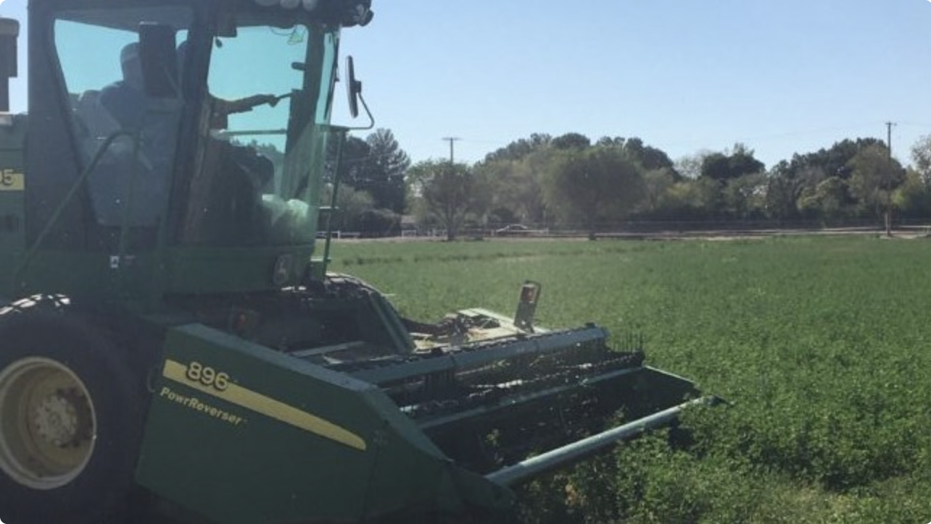
For the last several years, former agriculture teacher Armando Flores has worked with Coronado students to show them that being a future farmer as a profession is important, valuable work. Each year, Flores works with 15 students who are interested in pursuing a career in agriculture and the food production industry. These students work with Flores on a 36-acre alfalfa farm and perform tasks including handling livestock, producing crops, working with tractors and more.

“These days, each farmer is responsible for feeding 200 people," said Flores. "Those numbers are just absolutely crazy. I've got a little baby girl at home and every single day I think about it. What’s next? Who is going to be next if we are not feeding the world? It may not be a crisis in my lifetime, but it is coming whether you like it or not."

FFA Member Connects Food Pantry with Fresh Produce
Mansfield Legacy High School student Reagan Powers, was selected as one of 10 Ford Leadership Scholar selected out of 135,000 FFA members for the 2019-2020 school year. Tasked with developing a substantial and sustainable community service capstone project, Reagan decided to build a greenhouse and garden to provide the Harvesting in Mansfield Food Pantry with a steady supply of fresh fruits, greens, and vegetables. With Regan’s legacy project, the food pantry will be able to feed nearly 2,000 families a week with packages that include meat, cooking staples, drinks, and now freshly grown food.

“About 16,000 of Mansfield high school students go hungry, and it’s kids that I’m sitting next to in class,” Powers said. “And I don’t even know that they are missing a meal or on free or reduced lunch.” Regan’s project, Feeding the Future, will be continued on by her FFA chapter.
FAQ

What is the Texas Future Farmers of America (FFA)?
Founded in 1929, the Texas FFA’s mission was to offer greater opportunity for self-expression, leadership development, and a sense of pride in one’s work. The FFA now connects STEM to the real world through hands-on projects that make classroom learning meaningful and applicable. By teaching students how to creatively solve real world problems with modern science and technology, the FFA is training the leaders of tomorrow.
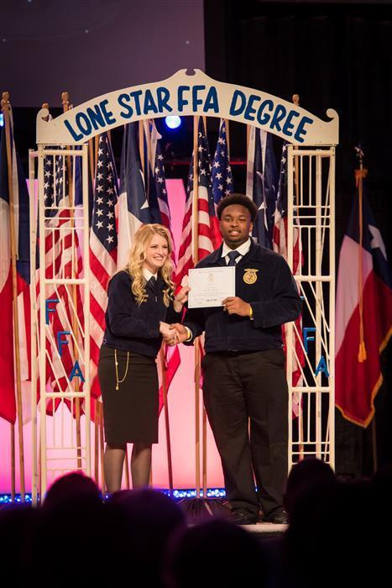
Who is part of the Texas FFA?
The Texas FFA is more than 137,530 members strong. From middle schoolers to seniors, urban to rural, FFA members are a diverse group that include everyone from star athletes to National Honor Society award winners. We are the scientists, marketers, CEOs, designers, entrepreneurs and leaders of tomorrow.

What does agriculture have to do with science?
In one word: Everything! According to the United Nations, the world will require 70 percent more food by 2050, which must be achieved with the same land we have today. The UN believes that this food must come from science that improves and enhances efficiency, which means the Texas FFA’s focus on all facets of agriculture, from the mechanics of farming all the way to engineering and technology, are a big part of solving tomorrow’s biggest problems.

What real world experiences do FFA students discover?
In the FFA, we believe students learn by doing, which is why we do so much. FFA makes classroom learning real through a variety of hands-on opportunities, from public speaking to conducting meetings, managing budgets, volunteering, and engaging in real world competitions and exhibitions. FFA students also plan the annual FFA convention, which is the largest youth led convention in Texas and one of the five largest overall conventions in the entire state.

What are some recent examples of FFA student work?
FFA students are some of Texas’s best and brightest. Recently, some of our youngest members created a mobile aquaponics tank and toured it around the state. Members are also a regular part of The Longhorn Project at NASA’s Johnson Space Center, and each year, the Ford Leadership Scholars program selects 10 promising FFA members based on action, relationships, vision, character, awareness, and continuous improvement.

Texas FFA Corporate Sponsors

Each year, the Texas FFA facilitates the distribution of more than $2.3 million in scholarships, thanks to the generosity of sponsors who believe in the power and possibility of agricultural science education. Sponsors recognize that FFA members are ethical, reliable, and articulate, which is why they continually support FFA members through generous scholarships, programs, internships, and job opportunities.

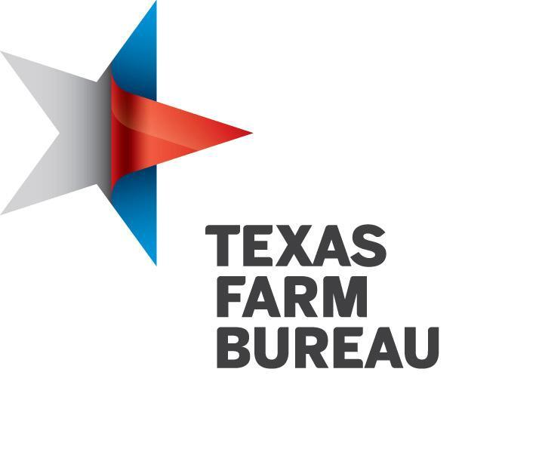

Texas FFA Academic Scholarship & Award Sponsors

Including Charles Scruggs and Family, Anne and George Butler Foundation, J. Lawson Sowell Memorial, Vicky Rosenbusch Memorial
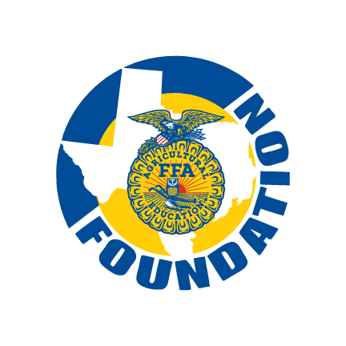
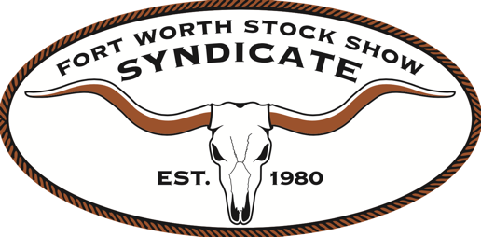
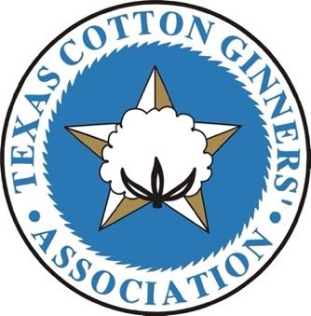
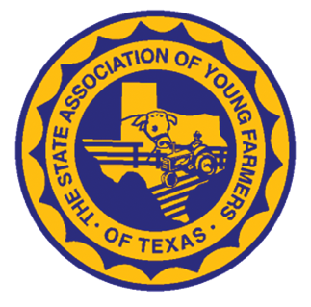
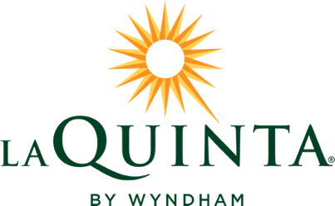
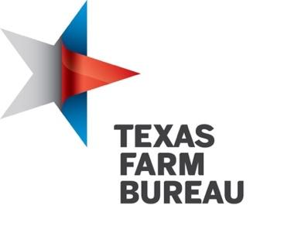
Fact Sheet

Why We Share Pride in the Blue and Gold

- The Texas FFA is more than 137,530 members strong, making it one of the largest state memberships in the national FFA organization.

- The Texas FFA has grown by more than 81,000 members from 2000 to 2020.

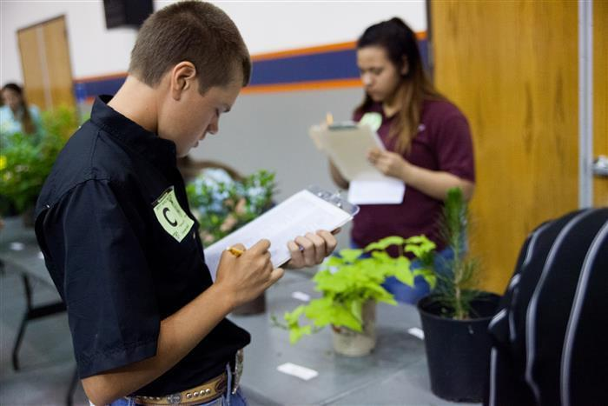
- Since the National FFA Foundation’s founding in 1944, sponsors have contributed more than $200 million to support the organization’s educational initiatives.

- More than $2.3 million in scholarships are awarded annually in Texas alone.

- Each year, students plan and execute one of the five biggest conventions in Texas.

- Though some FFA members eventually become full time farmers or ranchers, most FFA students apply the skills learned in agricultural sciences to careers in business, computer applications, math, science, technology, accounting, mechanics, engineering, and more.

- Some FFA students get creative and apply FFA skills to part time jobs that help pay for their degrees or supplement income; for example, a student who takes floral design courses can become a weekend florist and earn extra income. There are limitless ways the FFA helps dreams come true.

“Science and technology must spearhead agricultural production in the next 30 years at a pace faster than the Green Revolution did during the past three decades.”
—Dr. Jacques Diouf, Director-General, Food and Ag Organization of the United Nations.

Where Do You Fit?

The FFA has a place for every student. Here’s a sampling of some of the real-world training courses Texas agricultural education offers.

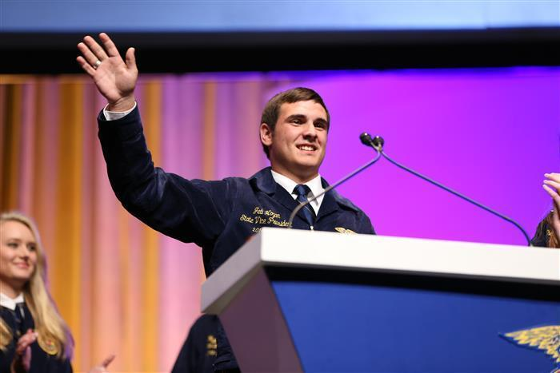
  - Professional Standards in Agribusiness
  - Agribusiness Management and Marketing
  - Mathematical Applications in Agriculture, Food, and Natural Resources
  - Equine Science
  - Livestock Production
  - Small Animal Management
  - Veterinary Medical Applications
  - Advanced Animal Science
  - Energy and Natural Resources Technology
  - Oil and Gas Production
  - Food Technology and Safety
  - Food Processing
  - Wildlife, Fisheries, and Ecology Management
  - Forestry and Woodland Ecosystems
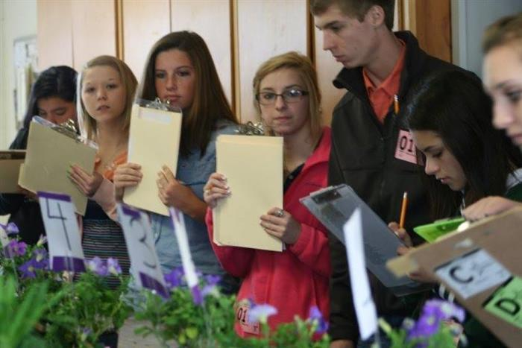
  - Range Ecology and Management
  - Floral Design
  - Landscape Design and Management
  - Horticulture Science
  - Greenhouse Operation and Production
  - Advanced Plant and Soil Science
  - Agricultural Mechanics and Metal Technologies
  - Agricultural Structures Design and Fabrication
  - Agricultural Equipment Design and Fabrication
  - Agricultural Laboratory and Field Experience

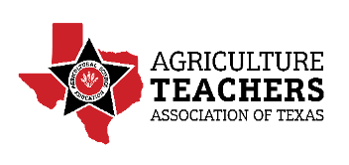
Team Ag Ed Leadership
Ray Pieniazek
Executive Director, Agriculture Teachers Association of Texas (ATAT)

Ray Pieniazek has spent his entire career working with agricultural students and teachers. After graduating from Texas A&M in 1988 with a Master of Education in Agricultural Education, Pieniazek began his career as an Agricultural Science teacher in Poth, Texas. He moved to Houston and spent 11 years with Clear Lake High School. Throughout those 11 years, Pieniazek was the NASA Longhorn Project teacher coordinator.

Before joining ATAT as Executive Director, Pieniazek spent 18 years working at East Central High School as the lead teacher for the agricultural department and worked with the CTE department. Throughout his thirty-year career as a teacher, he helped lead his students to earn significant FFA achievements including two state vice presidents, five state leadership development event finalists, 15 National CDE Qualifiers, eight National FFA CDE Champions, 28 American FFA Degree Recipients, 194 Lone Star FFA Degree Recipients, six Area FFA Officers and 19 District Officers.

In 2019, Pieniazek was invited to join ATAT as its Executive Director. In his present role, Pieniazek manages the 2,200 plus members of the teachers' association and coordinates professional development conferences to provide training for teachers. Pieniazek also serves on the Board of Directors for the Texas FFA, Texas FFA Foundation and ATAT Credit Union.

Texas FFA Programs that Shine

At New Waverly High School, the FFA launched an agricultural robotics (aka, agrobotics) team that teaches core engineering skills so students can better solve specific, real world problems with technology. Students leverage the scientific method to hypothesize, invent, experiment, and refine solutions until they develop the most efficient design.

Team Ag Ed Leadership

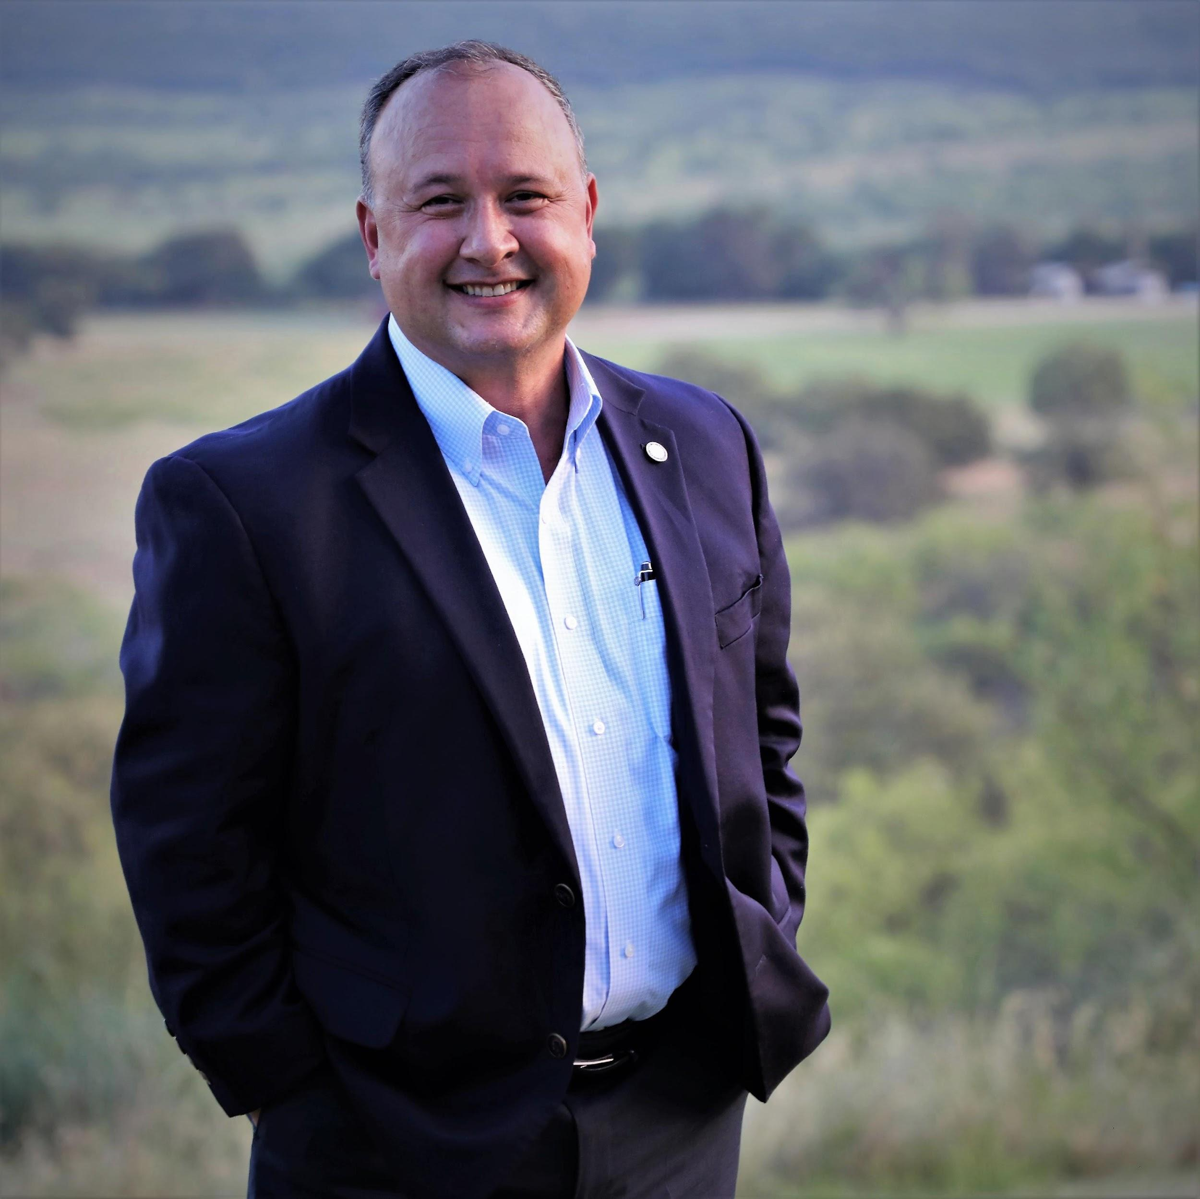
Aaron Alejandro
Texas FFA Executive Director, Texas FFA Foundation

As an executive director with the Texas FFA, Aaron Alejandro has established relationships with key sponsors and individuals to help make countless dreams come true and widen the doors of opportunity for more than 137,530 members statewide. Alejandro established the Star Partnership and Convention Partners Program, which generated record levels of donor support. His newest initiative, MYTEXASFFA.ORG, represents a true innovation in advocacy, engagement, and stakeholder connection.

In 2020, under Alejandro’s leadership, the Texas FFA Foundation recorded more than $13 million in endowment and financial assets, which represented a 377% net asset growth since he joined the organization in 2000. The models he has created for record fundraising for the Texas FFA Foundation and the annual state convention is now being used by numerous other state FFA foundations.

Alejandro also consults with businesses, organizations, and youth clubs about ways to improve organizational and individual performance. As an inspirational speaker, Alejandro’s unique style offers a clear message of personal dynamics for success that transcends age groups and corporate cultures.

Texas FFA Programs that Shine

At Florence High School in central Texas, FFA members run a complete meat processing laboratory and full-service meat market. The Florence Meat Science Program gives students firsthand experience of meat processing and fabrication. Students graduate with a comprehensive knowledge of the meat processing industry, and program graduates receive their meat processing certification and can begin immediate employment earning wages above entry level.

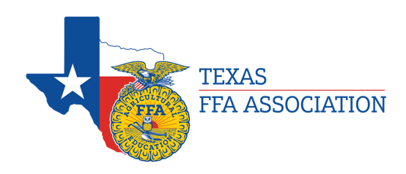
Team Ag Ed Leadership

Austin Large
Texas FFA Executive Director, Texas FFA Association

Austin Large joined the Texas FFA as an executive director in February 2017. Prior to joining the organization, Large was an education specialist on the leadership development team with the National FFA organization in Indianapolis for two years, where he developed, evaluated, revised, and managed FFA educational programs. He was also a leadership development coordinator for the Texas FFA Association, where he oversaw leadership programs and initiatives, managed the student officer team, and orchestrated session activities for the annual state convention.

Large earned his Bachelor of Science degree in agricultural science and education from California State University Chico, then his master’s degree in agriculture and consumer resources from Tarleton State University. He was a leadership trainer for the California FFA Association while he was an undergraduate, and later taught agriculture for four years with Esparto High School and Minarets High School in his home state of California. His background at the local, state, and national levels within the FFA made him an ideal fit for the Texas FFA executive director role.

Texas FFA Programs that Shine

The James Madison High School AgriScience Magnet Program includes a 20-acre complex on campus that offers seven pathways of study: agribusiness, agriculture mechanics, animal science, environmental science, floriculture & plant science, food processing and veterinary technology. The complex is equipped with several different laboratories that give students ample hands-on training. Through their lab work, students can obtain industry recognized certifications in agriculture mechanics, animal science, environmental science, floriculture, and veterinary technology, and dual credit courses allow students to earn college credits while still in high school.

Team Ag Ed Leadership
Leslie Hudson
Statewide Career and Technical Education Coordinator,
Texas Education Agency

Leslie (Les) Hudson is a statewide career and technical education (CTE) specialist for the Texas Education Agency. His responsibilities include direction of the agriculture, food and natural resources programs. He holds a bachelor’s degree from Texas A&M in College Station and master’s degree from Lamar University in Beaumont.

Hudson’s career encompasses teaching agriculture in Brackettville for three years and in Bastrop ISD for 17 years before moving into an administration position within the district.

During his 10 years of administration at Bastrop ISD, Hudson held the title of assistant principal, director of CTE and director of student services. He helped implement and oversee the effectiveness of behavioral response to intervention (RtI), positive behavior interventions and support (PBIS) as well as social emotional learning for the district.

In June 2019, Hudson joined the Texas Education Agency as CTE educational specialist overseeing and providing strategic planning for the agriculture, food and natural resources, architecture and construction career clusters. Hudson serves on the Board of Directors for the Texas FFA Association and the Texas FFA Foundation. He is also a member of the State of Texas Agriculture, Food and Natural Resources Industry Advisory Committee and the BISD Improvement Committee.

Hudson is the proud father of two former CTE students and FFA members Caleb and Kendall. He and his wife Dawn live outside of Bastrop where they are actively involved within the agriculture community.
Texas FFA Programs that Shine

The Jacksboro ISD Student and Teacher Memorial Courtyard was constructed by leadership efforts from FFA member Hunter Hackley. “This courtyard teaches students the importance of leaving a strong legacy by continually reminding them of the amazing impressions left by the individuals on the memorial. The greatest thing I have gained from this whole process is the ability to professionally complete an extensive project in a real-world setting. There is no other program in the country that challenges students to complete such elaborate and difficult projects,” said Hackley.
Media Contacts

Amy Power
amy@thepowergroup.com
214.693.2146

Julia Monter
julia@thepowergroup.com
972.415.3434

Kiara McKinney
kiara@thepowergroup.com
972.951.6966

